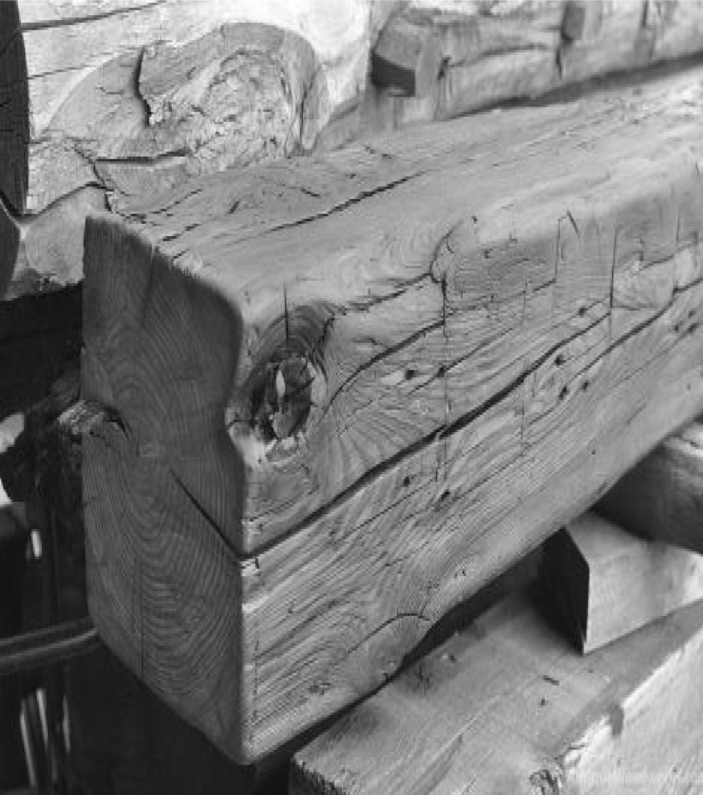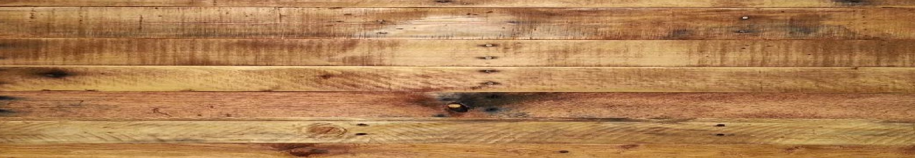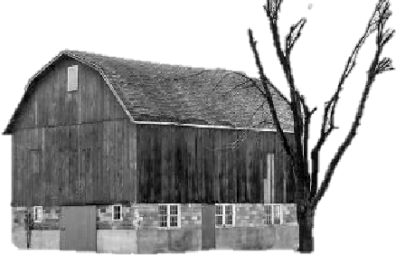

Collective Décor, LLC

www.collectivedécor.net

Spring 2018

Rustic Home Accents

(

Custom Built Floating Shelve

s, Mantels a

nd Beams

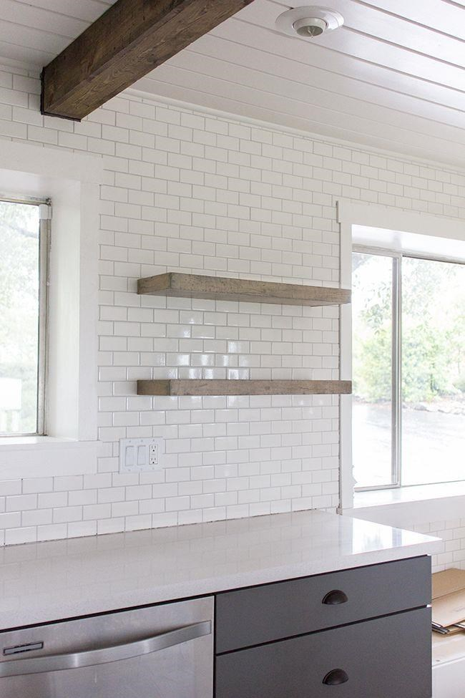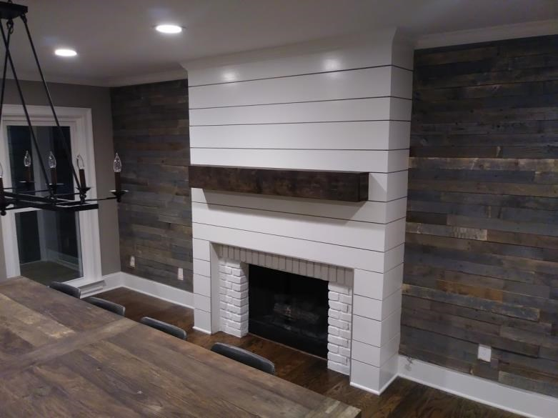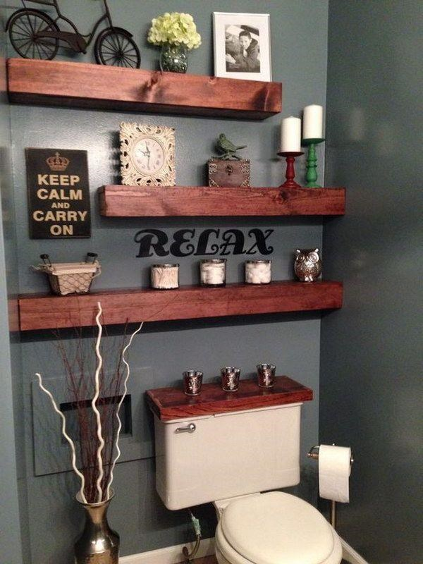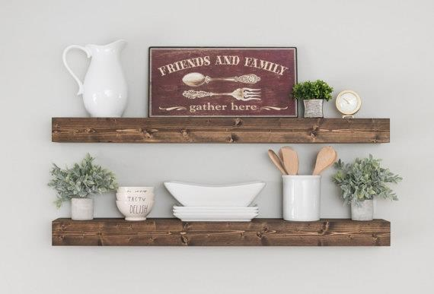

Floating

Shelves

2

ft Shelf

2

’L

wL

x

44

4”

P

x

5

½”

D

$

6

9.

99

3

ft Shelf

3

’

L

x

4

”

P

x

5

½”

D

$

79.99

4

ft Shelf

4

’

L

x

4

”

P

x

5

½”

D

$

89.9

9

Fireplace

Mantels

6

ft Ma

ntel

$550.00

7

ft Mantel

$650.00

www.collectivedécor.net

East Cobb

Kitchen

Du

nwoody Living Room

Brookhaven Dining Room